Mohamed Sondo Prof Zhu Computer Vision(cs 471)

09/16/2017 Assingment 1

1. Writing Assignments
2. How does an image change (e.g., objects' sizes in the image, field of view, etc.) if the focal length of a pinhole camera is varied?

Using the perspective camera model, x = f.X/Z, and y = f.Y/Z. The image size changes linearly with the focal length f, the larger f the larger the image, and vice versa. The image area changes quadratically with f. There are two effects: size and shape of object images changes linearly with focal length f field of view (FOV) is increasing with decreasing f and vice versa, i.e. with shorter f we see more of the scene. In the PinHole Model, A 3d world is map into a 2D.Through the small hole(pin), a ray of light is inverted . An inverted dimished image of the object if formed. Light ray from the otop of the object travel in as straight line and fall at the botton on of the screen and vice versa for the botton ray light. If the Hole if larger, then the image formed will be blurd. The Transformtion is given by the following equation. If we manipulate the formulate in the picture we can see that an increase in the focal lens of the camera will bigger x and y value, meaning bigger image. The opposite will happen when the focal lens is decrease( image will move more from left to right.

(2). Give an intuitive explanation of the reason why a pinhole camera has an infinite depth of field.

Each scene point emits one ray that passes through the hole onto the image plane. There is only one ray per point P that creates p, and therefore every P independent of the distance z creates a sharp picture in the image plane. The depth of field therefore is infinite

In the Pin Hole Camera Model, because, a perfect image is formed regardless of object or image location relative to the pinhole, which mean that this camera model has an infinite depth of focus. As light ray come in, the larger the camera's hole, higher the number of light rays that come into the camera. The ray light become very un-organized, and this causes focus blur. What a lens does is organize a part of these rays, so that the rays coming from a specific distance form a crisp image.  
-On pinhole cameras, the hole is so small that there are less light rays coming in, so they are already more organized, and that's why almost everything is in focus and the Depth of field for any camera photograph increases as the lens aperture gets smaller

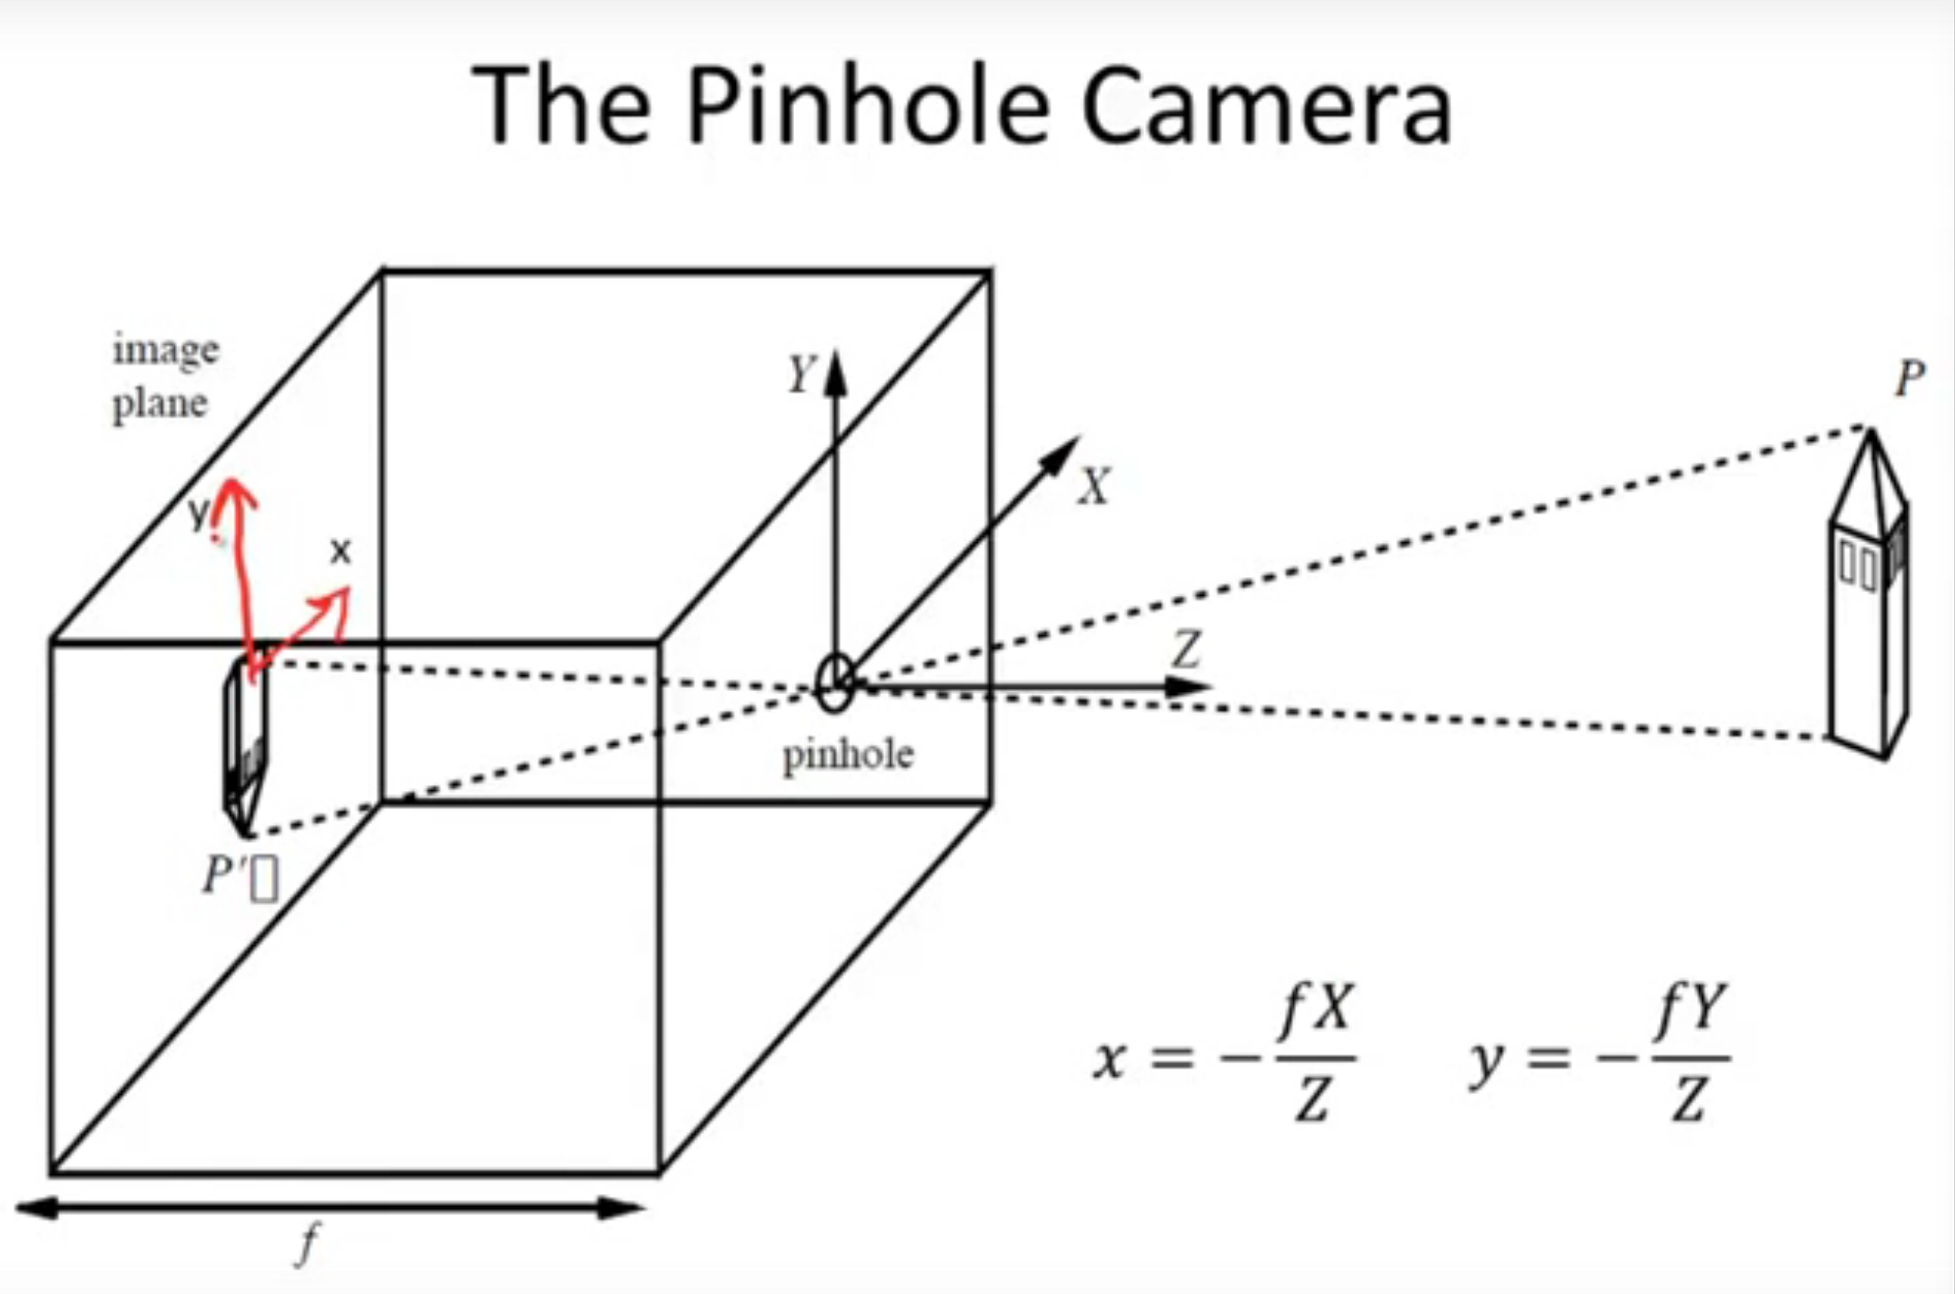

(3). In the thin lens model, 1/o + 1/i = 1/f, there are three variables, the focal length f, the object distance o and the image distance i (please refer to Slide # 19 of the Image Formation lecture). If we define Z = o-f, and z = i-f, please write two a few words to describe the physical meanings of Z and z, and then prove that Z*z = f*f given 1/o + 1/i = 1/f.

Thins lens are optical device that refract light to form an image.

Any ray parallel to the axis on one side of the lens passes through the focal point on the other side

Any ray that passes through the center of the lens will not change its direction

f-is the focal length. (distance from the center of lens to the focal point). For convex lens( f is positive and negative of concave lens)

o-represent the object distance, measure from the center of lens to the object. Always positive.

1. Image distance. From lens to image location.

In the formula Z*z = f*f given 1/o + 1/i = 1/f, as Z get larger, z approaches f

As Z approaches f, approaches infinity.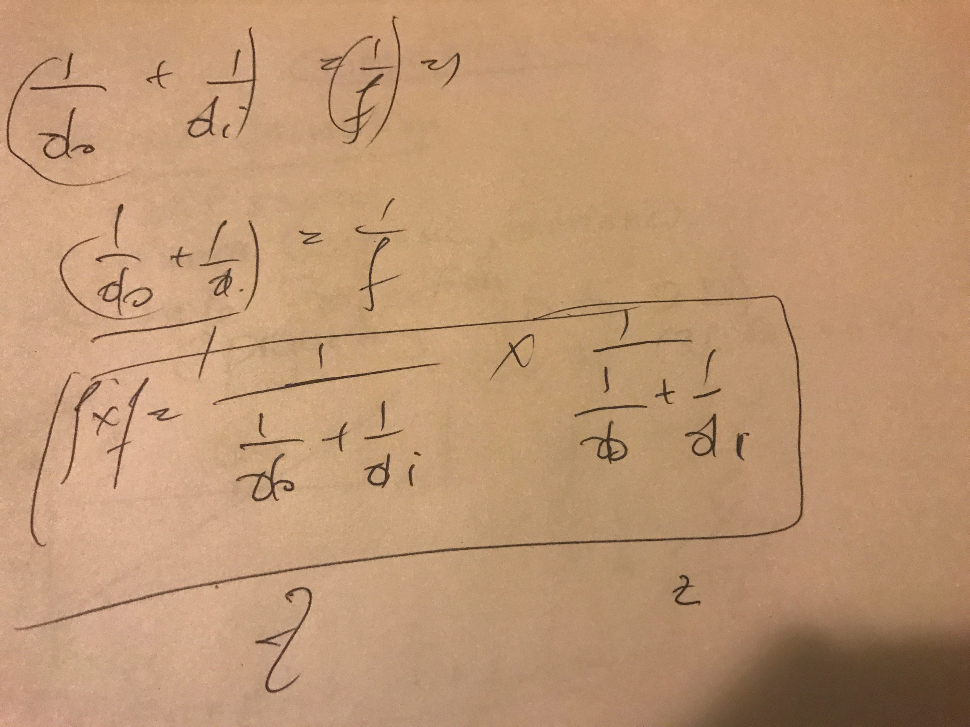

(4). Prove that, in the pinhole camera model, three collinear points (i.e., they lie on a line)  in 3D space are imaged into three collinear points on the image plane. You may either use geometric reasoning (with line drawings) or algebra deduction (using equations).

Pin Hole Camera model, project 3D image to 2D. We are in way losing one Dimension.

As we already know that points on a straight line are imaged to a straight line, the same is true for collinear points as these are all imaged to a line, where by definition points are collinear. Formally, we can also choose two 3D scene points, project them into the image plane, then choose a third scene point that lies on the line defined by the 2 points. It can be easily shown that the image of this 3rd point indeed is part of a line through the images of points 1 and 2. Or, coming up with a line equation for a line in 3D space with parameter t, we can substitute with the equations for the pinhole camera. It can be shown that the resulting line equation is again linear in t. straight line in scene: X(t) = X0 + tU, where U is (X2-X1) pinhole camera: x = -f(X/Z), similarly for y image plane: substitution: x = -f(X0 + tU)/(Z0 + tW), similarly for y

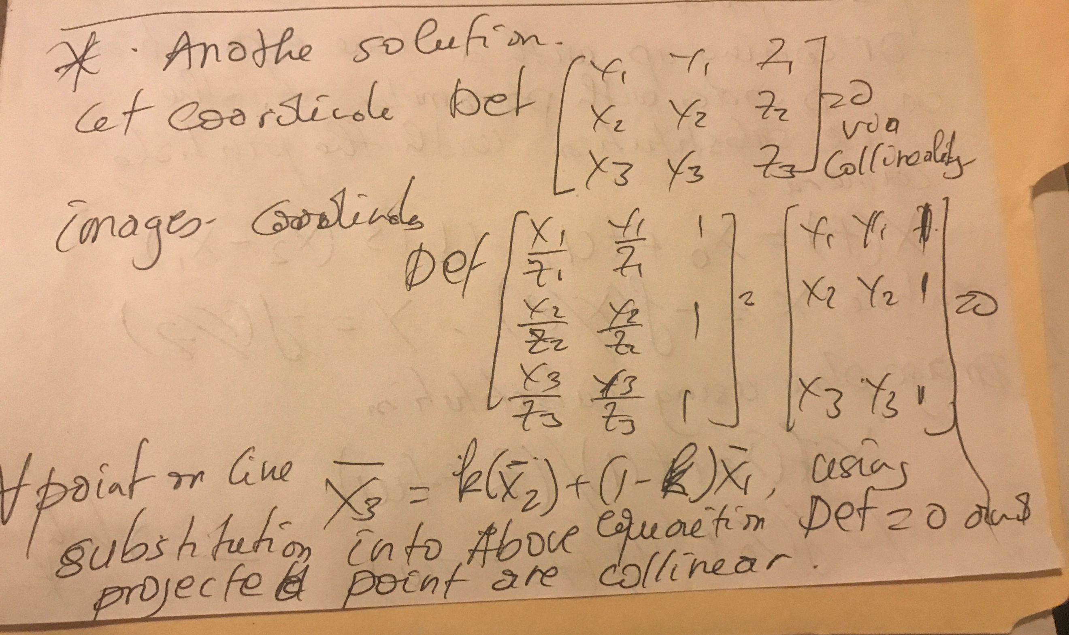

**2. Programming  Assignments**

1. Read in a color image C1(x,y) = (R(x,y), G(x,y), B(x,y)) in Windows BMP format, and display it.

